How to submit a video for Youth & Elder’s Honoring
- Be sure to RSVP for the event at bit.ly/YEH2020
- Identify a device that you can record video with and send video from easily. (i.e: cell phones, laptops, digital cameras, etc.)
- Select a good backdrop, where will you be shooting this video? Consider what is happening in the background. Would you rather be shot in front of an interesting landscape/picture, or a shower curtain?
- Read the prompt and read your answers out loud before recording and make adjustments. This will help your speech sound smoother. Consider not simply reading the card but remembering your answers and speaking directly to the camera. (below is the speech card.)
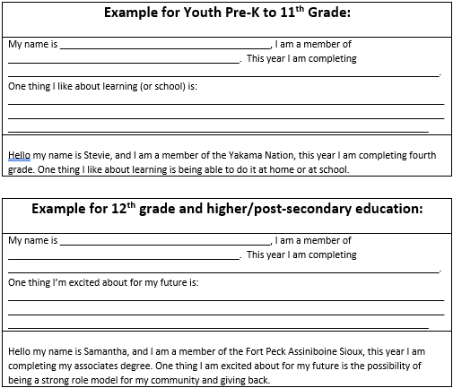
- You do not need to use your first take, practice a couple of times, and get the take you want. Very few times do you get to take a second shot at giving a speech.
- Either use the text function on your phone and send the video to SageH@nayapdx.org or upload the video to your computer and send it to the above email. As stated above, the video you send, will be the video used in the event, make sure you like it. Please send the videos prior to May 27th to guarantee it makes it into the final cut of the compilation.
- Show up the day of the event and get excited to be a part of the first ever virtual Youth & Elder’s Honoring!

